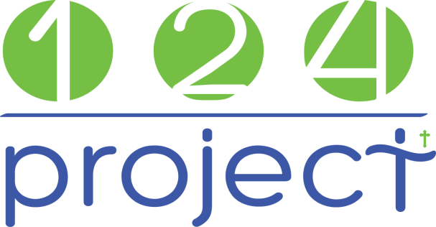

Application for Internship
Today’s Date: _____________
- Contact Details
  - Legal Name (as written on passport): _______________________________________________________
Name you go by: ________________________________________________________________________
  - Present Mailing Address: _________________________________________________________________
  - City: ______________________________ State: _______ Zip: ____________ Country: _______________
  - Phone, Home: __________________________ Cell: ______________________________________

  - Email: _________________________________________________________________________________
How often do you check this email? ___________________
  - Birthdate (M/D/Y): ______________ Age: ______ Gender: ______ Marital Status: _________

  - Name of Spouse: _____________________________________________ Birthdate (M/D/Y): __________

  - Children

Name | Date of Birth | Age

  - Employment: ______________________________________________________________________

  - Passport Number: ____________________ Expiration Date: ___________ U.S. Citizen? ________

- Short Answer Questions

  - Are you involved in a church? ___________________
If yes, what is your involvement? ______________________________________________________

__________________________________________________________________________________
  - Describe your health, include any chronic ailments or disabilities: ________________________________
__________________________________________________________________________________
  - Please list any previous short-term team experience ___________________________________________
__________________________________________________________________________________

  - Please list three of your strengths: _________________________________________________________

  - Please list three of your weaknesses: _______________________________________________________

  - How do you intend to raise your support? ___________________________________________________

  - List your skills _________________________________________________________________________

________________________________________________________________________________________

- Give a brief testimony on how you came to know Jesus Christ as Lord and Savior
___________________________________________________________________________________________
___________________________________________________________________________________________
___________________________________________________________________________________________
___________________________________________________________________________________________
___________________________________________________________________________________________
___________________________________________________________________________________________
___________________________________________________________________________________________
- References
Please list the names, addresses, and phone numbers of at least two people (non-family) who know you well and are willing to provide information about your potential service as a missionary. (Applications are not processed without references.)

Information | Reference #1 | Reference #2 | Reference #3
Name
E-Mail Address
Phone Number
Relationship

- Criminal Record

Have you ever been convicted of any unlawful offense (other than a minor traffic violation)? _____________

If YES, list the date(s) of the conviction(s) and crime for which you were convicted: _____________________

_________________________________________________________________________________________

- Have you ever been addicted to prescription or illegal drugs? _______________________________________

If YES, please explain: _______________________________________________________________________

_________________________________________________________________________________________

  - How long do you want to stay in Mexico? ____________________________________________________

  - Do you speak Spanish? ____________________________

_______________________________________________________ _________________
Signature Date

Please mail or deliver this application to:

info@124Project.org

Or mail to:
Cindy Shriver
124 Project Inc.
2613 Penfold Lane
Wake Forest, NC 27587

